Dis-Eur-France-Paris Basin-Middle Paleolithic Period-Levallois Method-Scraper-Flint-100,000 BP-30,000 BP

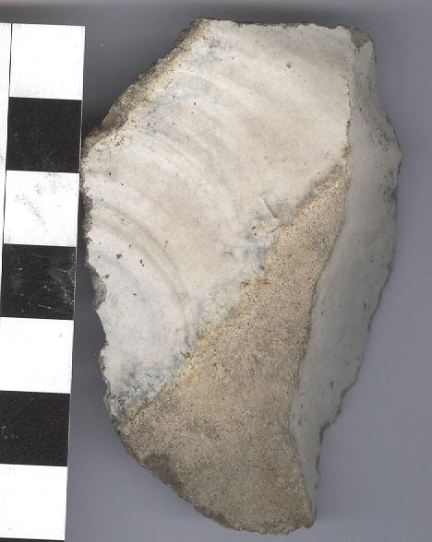

Fig. 1. Paris Basin-Middle Paleolithic Period-Levallois Method-Scraper-Flint-100,000 BP-30,000 BP

**Case no**.: 1

**Formal Label:** Paris Basin-Middle Paleolithic Period-Levallois Method-Scraper-Flint-100,000 BP-30,000 BP

**Display Description:**

This Paris Basin flint scraper with a blond to white patina of the Middle Paleolithic Period of the Mousterian type of debitage in the Levallois method, 100,000 BP-30,000 BP. Paris Basin patina is the result of an alteration of flint that transforms the cortex or rind from a white to blond coating by adsorption of calcium carbonates and other minerals (in the soil in an extremely long process that can reach a depth of 0.5 mm. This specimen shows an age toward the beginning of this time horizon.

**Accession Number:** A

**LC Classification:**

**Date or Time Horizon:** 100,000 BP-30,000 BP

**Geographical Area:** Paris Basin, near Ormesson, s of Paris

**Map, GPS coordinates:** [48°47′09″N 2°32′18″E](https://tools.wmflabs.org/geohack/geohack.php?pagename=Ormesson-sur-Marne&params=48.7858_N_2.5383_E_type:city%289937%29_region:FR-J)



**Cultural Affiliation:** Mousterian, *Homo erectus*.

**Medium:** Paris Basin Flint

**Dimensions:**

**Weight:**

**Condition: original.**

**Provenance: Excavated** under the auspices of CNRS, UMR 7041, Equipe d'Ethnologie préhistorique, MAE – 21 allée de l'Université, Hauts-de-Seine, 92023 Nanterre cedex, France.

**Discussion:**

The (2009) of an open-air site of Ormesson (Seine-et-Marne e France) dating to ca 29,000 cal. BP is related to a bison hunt and illustrates a late Mousterian habitation area. Mousterian remains include a lithic industry, a bone-working area, hearths and a red ochre processing station suggesting the application of these ground nodules to ritualized objects. In total this site provides a view of a series of integrated cognitive capacities of Mousterian *Homo erectus* during the Middle Paleolithic. This particular Levallois Method-Scraper is expertly flaked and illustrates this point!

**References:**

Bodu, Pierre; Salomon, Hélène; Leroyer, Mathieu; Naton, Henri-Georges; Lacarriere, Jessica; Dessoles, Mélina. 2014. “An open-air site from the recent Middle Palaeolithic in the Paris Basin (France): Les Bossats at Ormesson (Seine-et-Marne),” *Quaternary International,* 331: 39-59.